# Title: On the Main page. Clicking on “Детальніше” on the main banner-carousel (“Центр захисту тварин” section) leads to a non-existent page.

**Priority:** High

**Severity:** S4 Minor

**Environment:**Samsung Galaxy J7 Neo (720x1280 pixels, Android 9 OS)

**Steps to reproduce**

1. Open the Main page: [https://kmlvm.kyivcity.gov.ua](https://kmlvm.kyivcity.gov.ua/)

2. Slide to a “Центр захисту тварин” section on the Main banner-carousel.

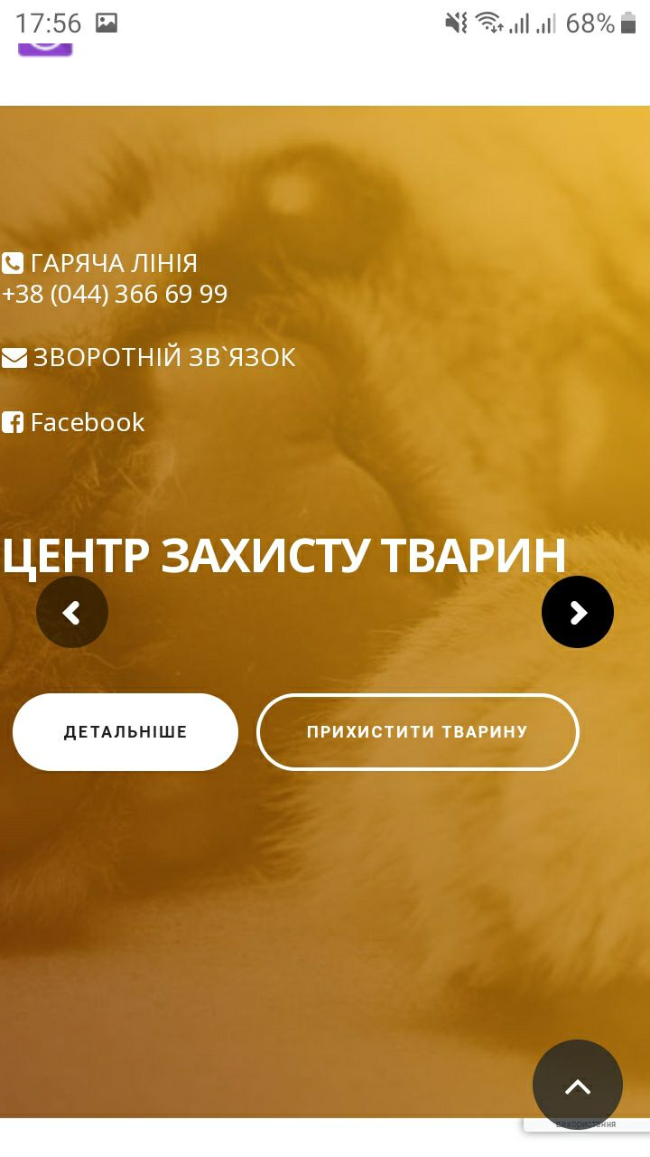

3. Click “Детальніше” button.

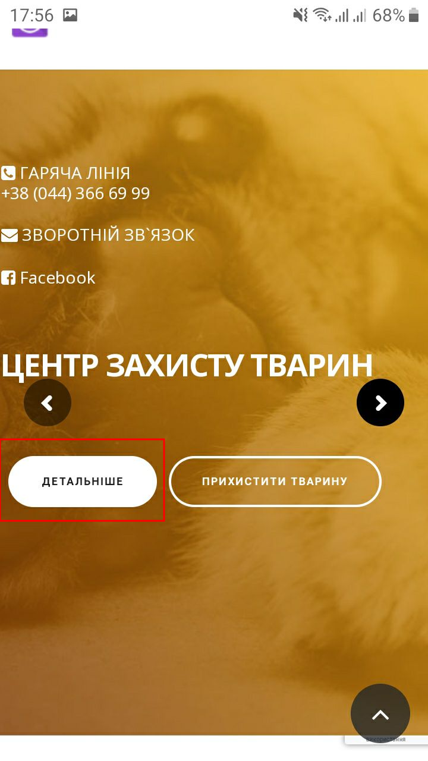

**Actual result**

Opens a technical page with a 404 error code (page is not existed).

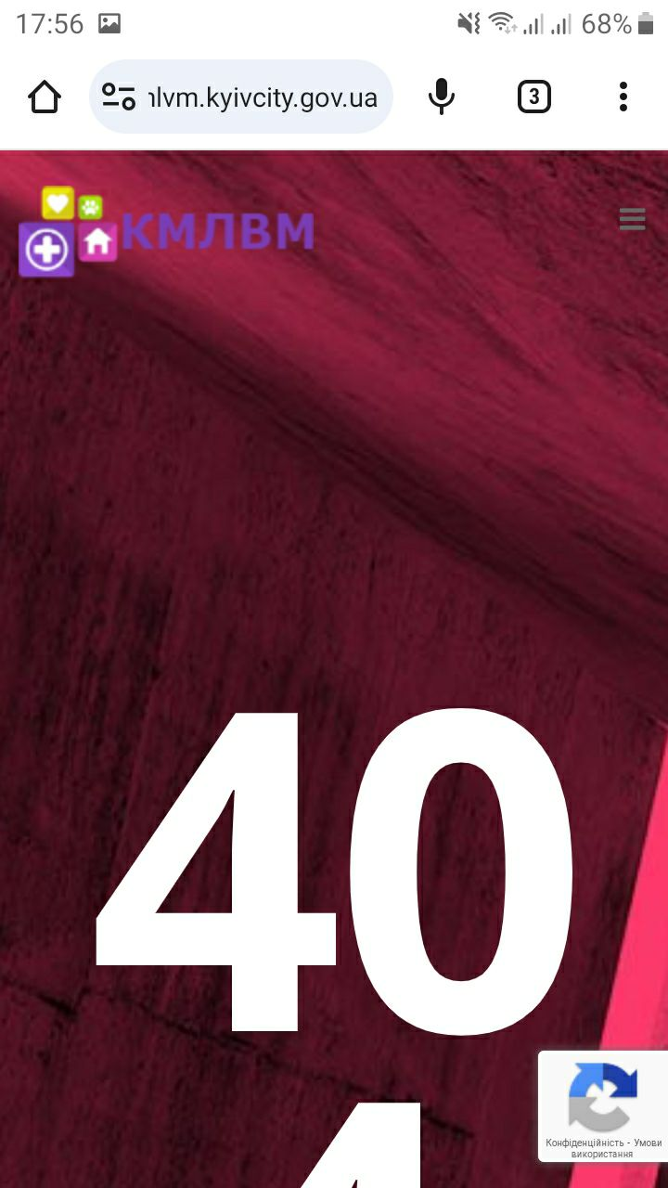

**Expected result**

Must be opened this page <https://kmlvm.kyivcity.gov.ua/tsentr-zahystu-tvaryn>

*Screenshot from* ***Jira****:*

